**SQL TASK -1**

**To create Database**

**create database task_1;**

**To create Table -1 (Employee)**

**create table employee**

**(**

**EM_ID int primary key AUTO_INCREMENT,**

**FIRST_NAME varchar(255),**

**LAST_NAME varchar(255),**

**SALARY INT,**

**JOINING_DATE date,**

**DEPARTMENT varchar(255)**

**)**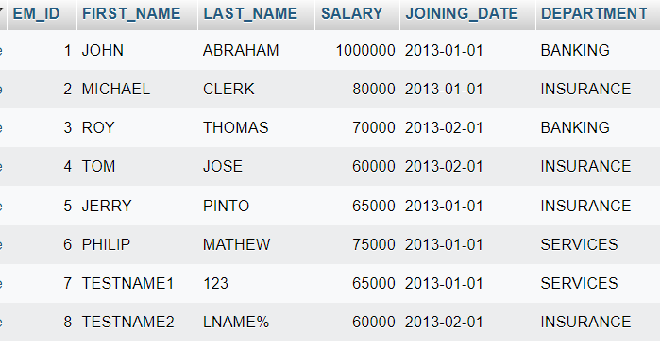

**To create Table -2 (Incentives)**

**create table incentives**

**(**

**insentive_id int primary key AUTO_INCREMENT,**

**EMPLOYEE_REF_ID INT,**

**INCENTIVE_DATE date,**

**INCENTIVE_AMT varchar(255)**

**)**

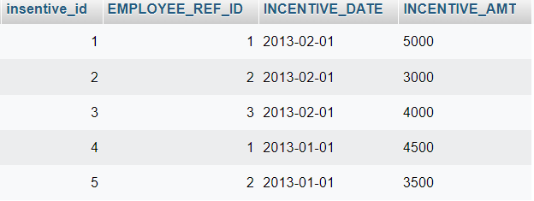

**A.Get First_Name from employee table using alias name “Employee Name**

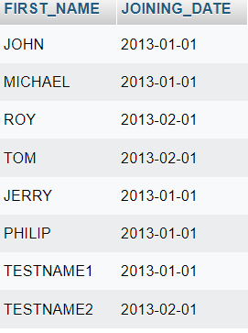

**c) Get all employee details from the employee table order by First Name Ascending And Salary descending?**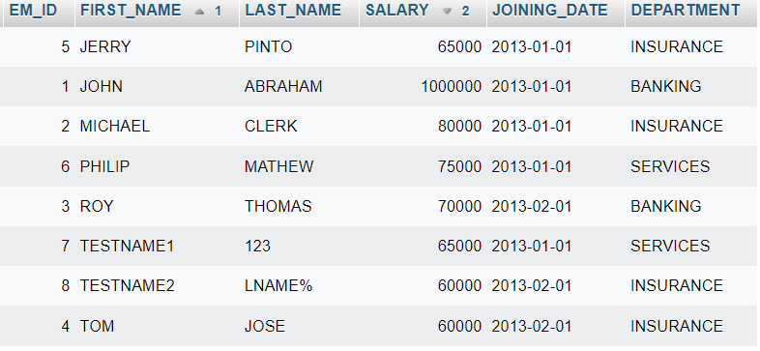

**D.Get employee details from employee table whose first name contains „o‟.**

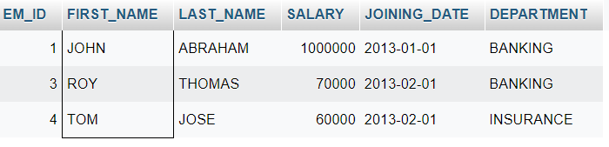

**e) Get employee details from employee table whose joining month is “January”.**

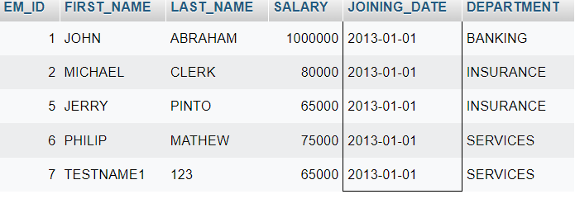

**f) Get department, total salary with respect to a department from employee table Order By total salary descending.**

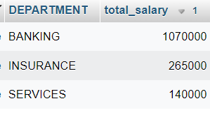

**G.Get department wise maximum salary from employee table order by salary ascending?**

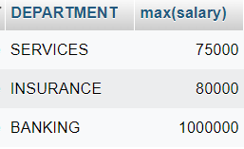

**h) Select first_name, incentive amount from employee and incentives table for those Employees who have incentives and incentive amount greater than 3000**

**select FIRST_NAME,incentive_amt from employee inner join incentives on employee.EM_ID=incentives.EMPLOYEE_REF_ID and incentive_amt > 3000;**

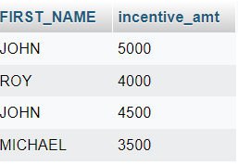

1. **Select 2nd Highest salary from employee table.**

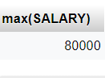

**j) Select first_name, incentive amount from employee and incentives table for all Employees who got incentives using left join.**

**select FIRST_NAME,INCENTIVE_AMT from employee left join incentives on employee.EM_id=incentives.EMPLOYEE_REF_ID;**

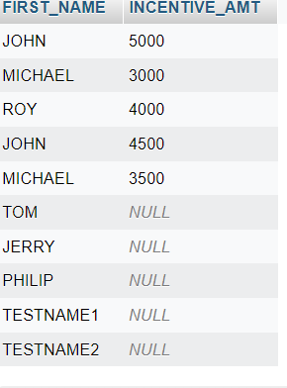

**K.Create View OF Employee table in which store first name, last name and salary only.**

**->create view multiview as select FIRST_NAME,LAST_NAME,SALARY from employee;**

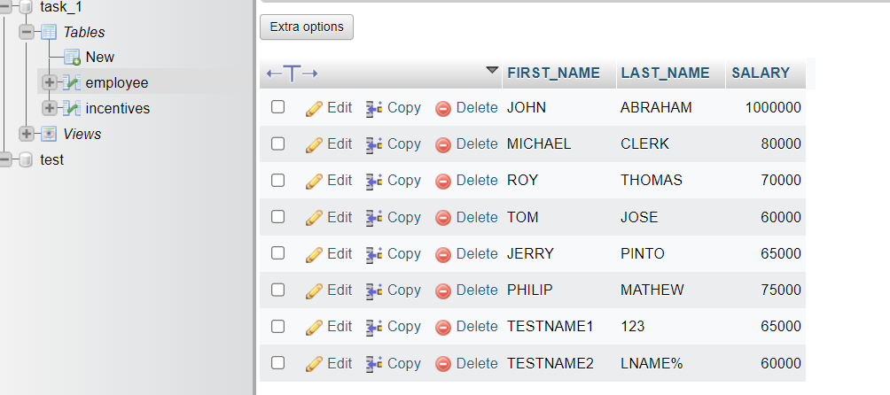

**l) Create Procedure to find out department wise highest salary**.

**select max(salary),DEPARTMENT from employee group by department order by max(salary) desc;**

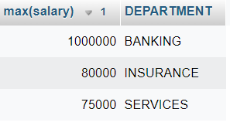

**m)Create after Insert trigger on Employee table which insert records in view table**

**SQL TASK -2**

* **To Create Table - 1 SALES_PERSON**

**create table CUSTOMER**

**(**

**SNO int,**

**SNAME varchar(255),**

**CITY varchar(255),**

**COMM int,**

**)**



* **To Create Table – 2 CUSTOMER**

**create table CUSTOMER**

**(**

**CNM int,**

**CNAME varchar(255),**

**CITY varchar(255),**

**RATING int,**

**SNO int**

**)**



* **To Create Table – 3 Order**

**create table ORDER**

**(**

**ONM int,**

**AMT float,**

**ODE date,**

**CNM int,**

**SNO int**

**)**

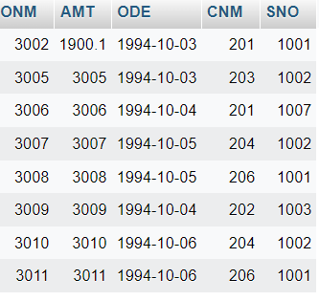

1. **All orders for more than $1000.**

**select * from order_1 where amt > 1000;**



1. **Names and cities of all salespeople in London with commission above 0.10.**



**c)All salespeople either in Barcelona or in London.**

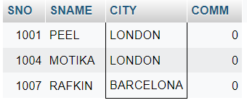

**D)All salespeople with commission between 0.10 and 0.12. (Boundary values should be excluded**



**e) All customers with NULL values in city column.**

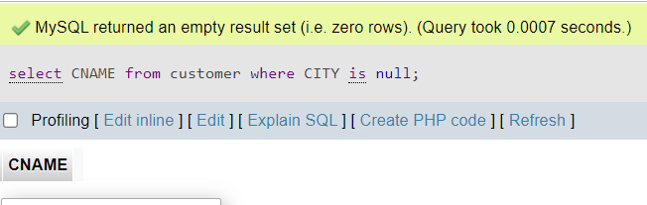

f**) All orders taken on Oct 3Rd and Oct 4th 1994.**

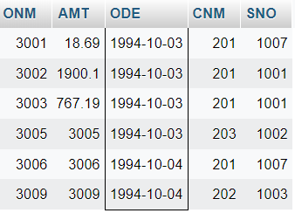

* **All customers whose names begin with a letter from A to B**

**SELECT cname FROM customer WHERE cname like 'A%' or cname like 'B%';**



**All customers excluding those with rating <= 100 unless they are located in Rome.**

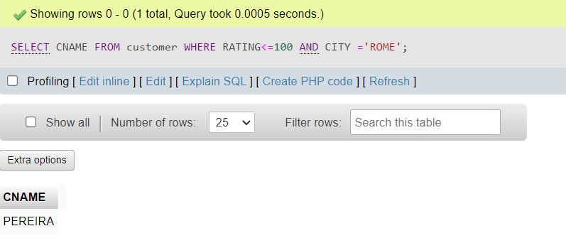

**All orders except those with 0 or NULL value in amt field.**

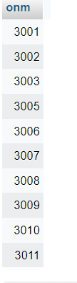

**Count the number of salespeople currently listing orders in the order table.**

